This entity relationship diagram explains about Hospital Management System (HMS). In the diagram there are six entities which are Room, doctor, Patient, Nurse, Prescription and Drug. The diagram shows the how each entity is related with other entity and what are the common attributes that can be used to make all entities work as one database system.

The rooms are staffed by nurses and occupied by patient. The nurse can be supervised by another nurse. The doctors are the primary care of patient where the patient receives prescription that provided by a doctor. Each prescription contains information about a specific drug.

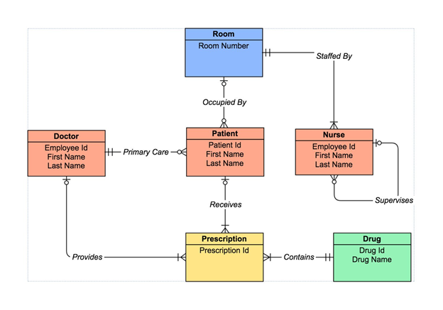

Room (**Roomno**)

* The primary key is Roomno and there is no foreign key.
* Each room is staffed by nurse and the number of nurses in a single room can be one or more. The relationship between Room entity and Nurse entity is one to many.
* Each room is occupied by patient and the number of patients in a single room can be zero or more. The relationship between Room entity and Patient entity is one to many.

Doctor (**Employeeid**, Firstname, Lastname)

* The primary key is Employeeid and there is no foreign key.
* The doctor is the primary care of patient and the number of patients cared by one doctor can be zero or more. The relationship between Doctor entity and Patient entity is one to many.
* The doctor is the provider of treatment prescription and can give one or more prescription to the patient. The relationship between Doctor entity and Prescription entity is one to many.

Patient (**Patinetid**, Firstname, Lastname, *Roomno, Employeeid*)

* The primary key is Patientid and there are two foreign key which are Roomno and Employeeid.
* Each patient is cared by one doctor only. The relationship between Patient entity and Doctor entity is many to one.
* Each patient is stand in zero or one room. The relationship between Patient entity and Room entity is many to one.
* Each patient is receiving zero or more prescription. The relationship between Patient entity and Prescription entity is one to many.

Nurse (**Employeeid**, Firstname, Lastname, Supervisorid, *Roomno*)

* The primary key is Employeeid and the foreign key is Roomno.
* Each nurse can be supervising for zero or more nurse. The Nurse entity have one to many (self-relations).
* Each nurse can be in one room only. The relationship between Nurse entity and Room entity is many to one.

Prescription (**Prescriptionid**, *Employeeid, Patientid, Drugid*)

* The primary key is Prescriptionid and there are three foreign key which are Employeeid, Patientid and Drugid.
* Each prescription is provided by one doctor only. The relationship between Prescription entity and Doctor entity is many to one.
* Each prescription is given to one patient only. The relationship between Prescription entity and Patient entity is many to one.
* Each prescription contains one drug only. The relationship between Prescription entity and Drug entity is many to one.

Drug (**Drugid**, Drugname)

* The primary key is Drugid and there is no foreign key.
* Each drug can be in one or more prescription. The relationship between Drug entity and Drug Prescription is one to many.